**Design Thinking Project Workbook**

**Don't find customers for your product but find products for your customers**

**1. Team**

**Team Name:The Chatbot**

**Team Logo (if any):**

**Team Members:**

1. G.V.L.Neha,Team Lead,2320090046@klh.edu.in
2. Yatam Rishitha,Client Insights,2320030338@klh.edu.in
3. K.Vihaari,collected data,2320090027@klh.edu.in
4. G.Hemanth Sai,research,2320030113@klh.edu.in

**2. Problem/Opportunity Domain**

**Domain of Interest: Education Technology (EdTech)**

**Description of the Domain: The education sector is increasingly integrating technology to improve learning experiences and make education more accessible. Key challenges include providing personalized learning at scale, enhancing student engagement, and bridging the gap between traditional teaching methods and modern digital tools. Opportunities exist to use AI-powered chatbots to offer on-demand tutoring, assist with administrative tasks, and support student mental health.**

**Why did you choose this domain?: The education sector has a significant impact on society, and there is a growing need for tools that make learning more effective and accessible. By leveraging a chatbot, we aim to address challenges like personalized learning support and instant feedback, which can help students achieve better outcomes. Additionally, the market potential for EdTech solutions is expanding, making this a strategic choice for innovation.**

**3. Problem/Opportunity Statement**

**Problem Statement: Students often struggle to get personalized academic support outside of classroom hours, leading to gaps in understanding and poor performance.**

**Problem Description: Many students face difficulties in accessing immediate assistance for their academic queries. Traditional tutoring options may not be affordable or available at the needed times, resulting in students falling behind. This issue affects a wide range of learners, especially those with limited resources.**

**Context (When does the problem occur): The problem arises when students are studying independently, particularly outside of regular school hours or during exam preparation.**

**Alternatives (What does the customer do to fix the problem): Currently, students might rely on online forums, search engines, or wait for the next available class to seek help. These alternatives often lack personalized feedback and can be time-consuming.**

**Customers (Who has the problem most often): Primary and secondary school students, university students, and adult learners pursuing self-study are most affected.**

**Emotional Impact (How does the customer feel): Students may feel frustrated, anxious, or discouraged when they can't find timely help, which can lead to a lack of confidence in their abilities.**

**Quantifiable Impact (What is the measurable impact): Poor academic performance, lower grades, or increased dropout rates may occur due to the lack of timely support.**

**Alternative Shortcomings (What are the disadvantages of the alternatives): Existing solutions may not offer personalized responses or be available on demand, making it hard to address individual learning needs effectively.**

**Any Video or Images to showcase the problem:**

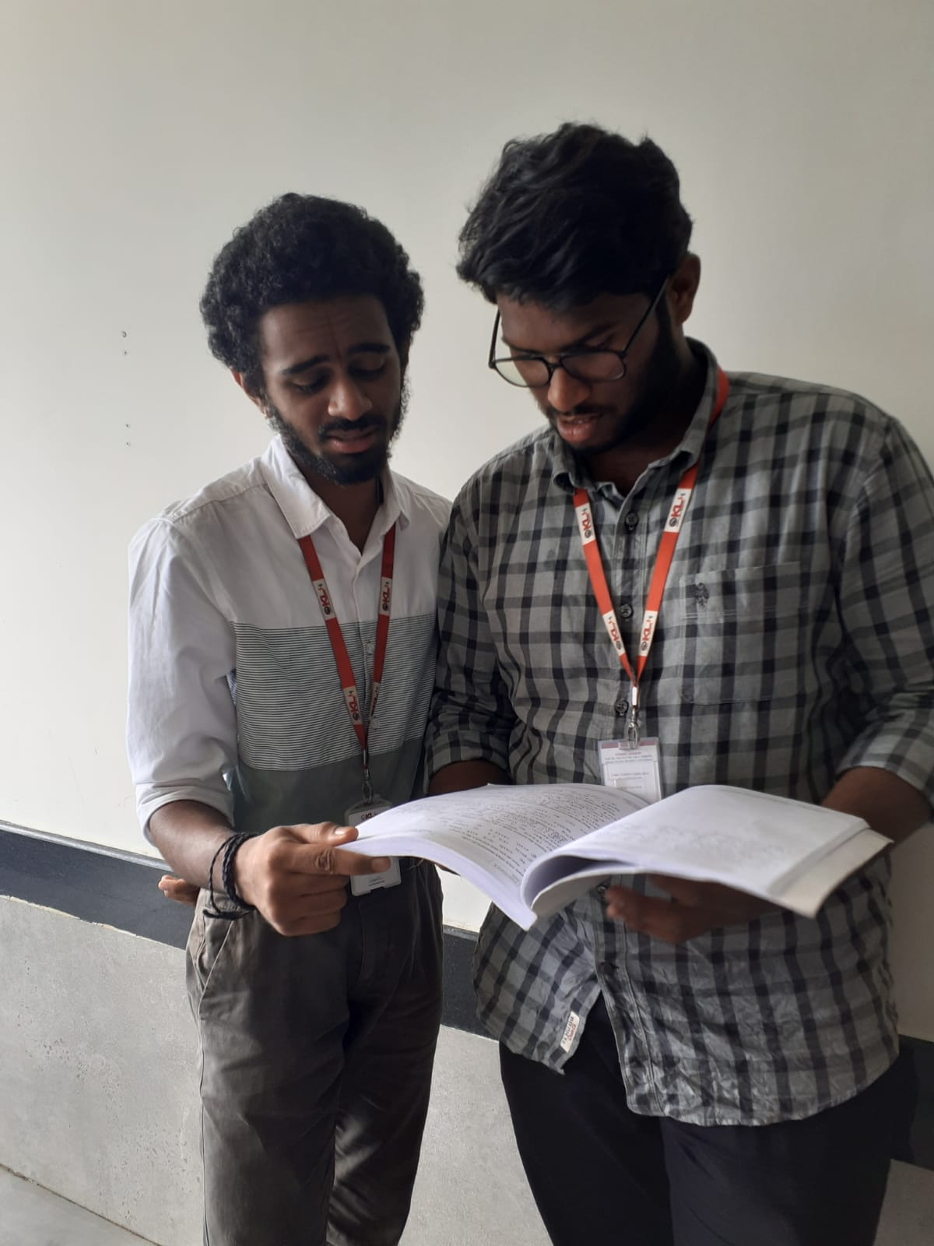

**3. Addressing SDGs**

**Relevant Sustainable Development Goals (SDGs): Quality Education (SDG 4): Ensuring inclusive and equitable education and promoting lifelong learning opportunities for all.**

**How does your problem/opportunity address these SDGs?: The chatbot helps bridge the educational support gap by providing accessible, personalized assistance to students. This supports equal learning opportunities and enhances students' understanding of the material, contributing to improved educational outcomes.**

**4. Stakeholders**

Answer these below questions to understand the stakeholder related to your project

1. **Who are the key stakeholders involved in or affected by this project?**

Students

Parents

Teachers

Educational institutions

Educational technology companies

1. **What roles do the stakeholders play in the success of the innovation?**

**Students**: Primary users of the chatbot, whose learning needs drive its features.

**Parents**: Support students and influence their use of educational tools.

**Teachers**: Provide insights on curriculum and student challenges, aiding in chatbot content.

**Educational Institutions**: Implement the chatbot as part of their learning resources.

**Educational Technology Companies**: Collaborate on development and maintenance.

1. **What are the main interests and concerns of each stakeholder?**

**Students**: Desire accessible, personalized help to improve learning outcomes.

**Parents**: Concerned about their children's academic success and well-being.

**Teachers**: Interested in tools that complement their teaching methods without replacing them.

**Educational Institutions**: Seek effective solutions that enhance student engagement and performance.

**Educational Technology Companies**: Focus on creating innovative, marketable solutions.

1. **How much influence does each stakeholder have on the outcome of the project?**

**Students**: High influence, as their feedback shapes the chatbot’s functionality.

**Parents**: Moderate influence through their support or skepticism.

**Teachers**: High influence by guiding curriculum integration and usage.

**Educational Institutions**: High influence if they adopt and promote the chatbot.

**Educational Technology Companies**: Moderate to high influence, depending on their role in development.

1. **What is the level of engagement or support expected from each stakeholder?**

**Students**: Active engagement in using and providing feedback.

**Parents**: Support in encouraging usage at home.

**Teachers**: Collaboration in curriculum alignment and promoting usage.

**Educational Institutions**: Support in implementation and promotion.

**Educational Technology Companies**: Ongoing support for updates and improvements.

1. **Are there any conflicts of interest between stakeholders? If so, how can they be addressed?**

Potential conflicts may arise between traditional teaching methods and the use of technology. Open communication and training can help address these concerns.

1. **How will you communicate and collaborate with stakeholders throughout the project?**

Regular meetings, feedback surveys, and collaboration platforms will facilitate communication.

1. **What potential risks do stakeholders bring to the project, and how can these be mitigated?**

**Risks**: Resistance to technology, varied levels of digital literacy.

**Mitigation**: Providing training and clear benefits of the chatbot to all stakeholders.

**5. Power Interest Matrix of Stakeholders**

**Power Interest Matrix: Provide a diagrammatic representation of Power Interest Matrix**

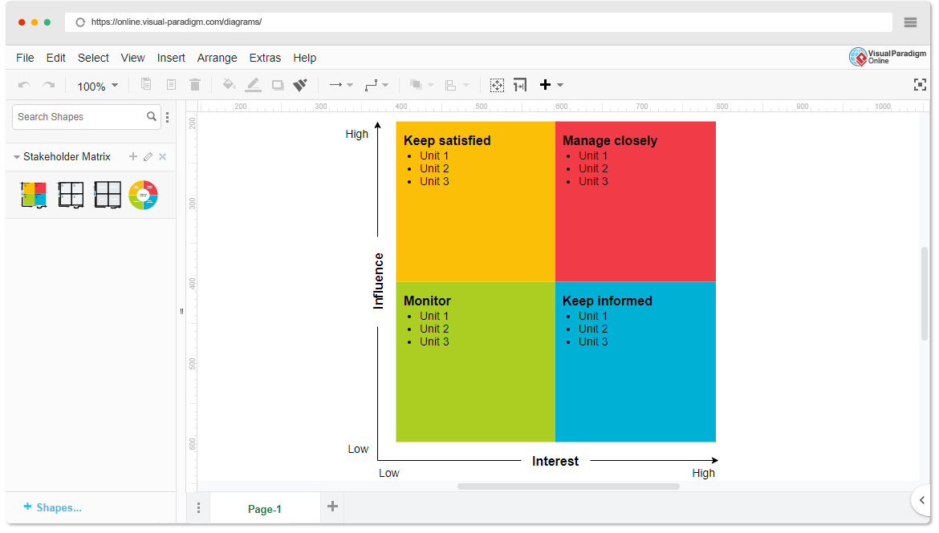

* High Power, High Interest: Educational Institutions, Teachers
* High Power, Low Interest: Educational Technology Companies
* Low Power, High Interest: Students, Parents
* Low Power, Low Interest: General Public

1. **Empathetic Interviews**

**Conduct Skilled interview with at least 30 citizens/Users by asking open ended questions (What, why/How etc) and list the insights as per the format below**

| **I need to know**  **(thoughts, feelings, actions)** | **Questions I will ask**  **(open questions)** | **Insights I hope to gain** |
| --- | --- | --- |
| Thoughts |  |  |
| What challenges do you face in learning? | Can you describe a time when you needed help with your studies? | Understanding specific moments of struggle. |
| What resources do you currently use? | What do you think about using a chatbot for academic support? | Gauging interest and perceptions about the solution. |
| Feelings |  |  |
| How do you feel when you struggle with a topic? | How do you usually find information when studying? | Learning about current resources and habits. |
| What emotions do you experience during exams? | What features would you want in an educational chatbot? | Identifying desired functionalities. |
| actions |  |  |
| What do you do when you need help? | How often do you study alone versus with others? | Understanding study habits and preferences. |
| How often do you seek academic support? | What barriers do you face when seeking help? | Identifying obstacles to accessing academic support. |

**SKILLED INTERVIEW REPORT**

**(Examples are given. Erase them and fill with your user information.)**

| **User/Interviewee** | **Questions Asked** | **Insights gained (NOT THEIR ANSWERS)** |
| --- | --- | --- |
| Abhishek Verma | What resources do you use for studying? | Many students rely on YouTube and online forums for help. |
| Srinivasan P.  Parent | How do you feel about online tutoring? | Parents appreciate online tutoring but worry about costs. |
| Emily R. | What challenges do you face in school? | Students often feel overwhelmed by the amount of content. |

**Key Insights Gained:**

* **Insight 1: Students value immediate and accessible support.**
* **Insight 2: There is interest in using technology to enhance learning, but concerns about effectiveness persist.**

**Empathy Map**

1. **Empathy Map**
2. **Who is your Customer?**

**Description: This is where you specify the customer or user you are empathizing with. It could be a specific user persona or a general user segment.**

**Key points:**

* **Define the customer profile clearly (e.g., age, profession, interests).**
* **State their goals and needs related to the innovation or product.**
* **Context in which the user will interact with your solution.**

1. **Who are we empathizing with?**

**Description: This area helps you define who the user is, what their situation looks like, and what role they play. It emphasizes understanding the user’s perspective in depth.**

**Key points:**

* **Define the user's characteristics (e.g., personality, values, and responsibilities).**
* **State the user's goals and challenges in their environment.**
* **What is the user's broader situation (professionally or personally)?**

1. **What do they need to DO?**

**Description: This section identifies what actions or tasks the user needs to perform. It helps highlight the expectations and demands the user faces.**

**Key points:**

* **Clarify the tasks or actions the user needs to complete.**
* **What decisions do they need to make?**
* **How do they define success or failure in their tasks?**

1. **What do they SEE?**

**Description: This focuses on the visual stimuli or environment that the user interacts with. It's important to consider what users see in their immediate surroundings and in their larger world.**

**Key points:**

* **What do users see in their physical and digital environment?**
* **What trends or competitors do they notice?**
* **How do these visual elements influence their behavior?**

1. **What do they SAY?**

**Description: This section captures what the user might say in public, such as comments or feedback they give in conversations or on social media.**

**Key points:**

* **What might users express openly in conversation about their problems?**
* **How do they express their goals or frustrations?**
* **What are their words during customer interviews or feedback?**

1. **What do they DO?**

**Description: This section focuses on what the user does, the actual behaviors they exhibit, and actions they take in different situations.**

**Key points:**

* **What observable actions do users take?**
* **What habits or routines do they follow?**
* **What might users do to try and solve their problems?**

1. **What do they HEAR?**

**Description: This addresses what information the user receives from external sources, such as colleagues, media, or industry trends. It helps map the influences surrounding the user.**

**Key points:**

* **What are they hearing from peers, mentors, or the industry?**
* **What media or channels of information are they exposed to?**
* **Are there any strong influencers guiding their behavior?**

1. **What do they THINK and FEEL?**

**Description: This is one of the most insightful sections, addressing the internal emotions, concerns, and motivations of the user. It helps identify their deep-rooted feelings.**

**Key points:**

* **What are their fears, worries, and anxieties?**
* **What are their motivations and desires?**
* **How do their thoughts and feelings align with their actions?**

1. **Pains and Gains**

**Description: This section focuses on the user’s frustrations and their desired outcomes. It helps to frame the user’s challenges (pains) and the benefits they seek (gains).**

**Key points:**

* **What are the user’s main pain points?**
* **What would make their life easier or more fulfilling?**
* **What benefits do they hope to achieve from your product or solution?**

**8. Persona of Stakeholders**

**Stakeholder Name:**

**Demographics: Key characteristics of your target audience, such as age, gender, income, and location.**

**Goals: What the stakeholders or customers want to achieve in relation to the innovation.**

**Challenges: The obstacles or difficulties faced by stakeholders that the innovation aims to address.**

**Aspiration: The long-term desires or dreams of your target audience related to the innovation.**

**Needs: The essential requirements of your customers or stakeholders that must be met.**

**Pain Points: Specific problems or frustrations experienced by the target audience.**

**Storytelling: A narrative that highlights the journey of the stakeholder or customer, illustrating the problem and how the innovation can solve it.**

**Sample:**

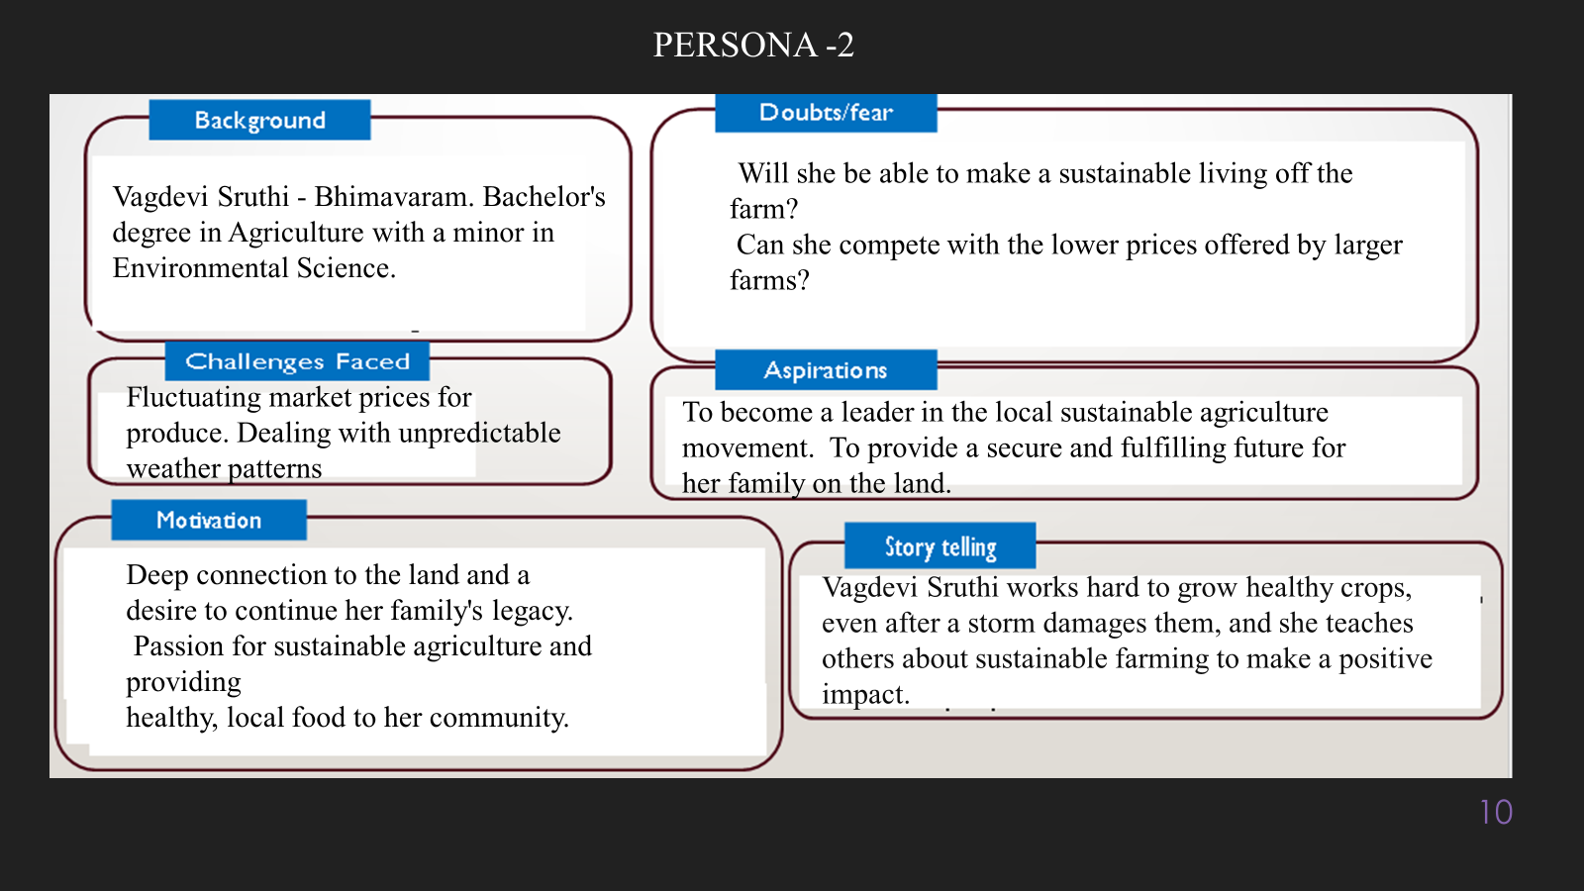

**10. Look for Common Themes, Behaviors, Needs, and Pain Points among the Users**

Analyse the data from your affinity diagram to uncover recurring patterns among your users, helping you better understand their expectations and challenges.

**Common Themes: Identify broad ideas or issues that repeatedly appear across different groups in your affinity diagram.**

**Common Behaviors: Observe how users consistently act or respond in relation to the problem or product throughout their journey.**

**Common Needs: Pinpoint essential requirements or desires that many users share, highlighting what they need for a better experience.**

**Common Pain Points: Look for frustrations or obstacles that frequently hinder the user experience, which your project can address.**

**12. Define Needs and Insights of Your Users**

**User Needs: Define the core requirements your users have in relation to the problem or product. These could be functional, emotional, or societal needs that your solution must address.**

**User Insights: Summarize the key understandings or observations you've uncovered about your users' behaviors, motivations, and pain points. These insights provide a deeper understanding of why users behave the way they do and what drives their decisions.**

**13. POV Statements**

**POV Statements:**

* [User] needs a way to [need] because [insight].

| PoV Statements  (At least ten) | Role-based or Situation-Based | Benefit, Way to Benefit,  Job TBD,  Need (more/less) | PoV Questions  (At least one per statement) |
| --- | --- | --- | --- |
| (Erase this example) When I drive to work, I want to avoid traffic jams so I don’t get in trouble with my boss for being late. | Situation | Way to Benefit | What can we design that will enable drivers to avoid traffic jams?  What can we design that will enable workers to avoid getting in trouble for being late to work? |
|  |  |  |  |
|  |  |  |  |
|  |  |  |  |
|  |  |  |  |

**14. Develop POV/How Might We (HMW) Questions to Transform Insights/Needs into Opportunities for Design**

Turn your user needs and insights into actionable opportunities by framing them as "How Might We" (HMW) questions. These questions will spark creative problem-solving and guide your innovation process.

1. **How Might We: Based on the needs and insights you've identified, create open-ended questions starting with "How might we...?" These questions should aim to solve user pain points, enhance the experience, or address specific needs.**

**Examples:**

* **User Need: "Users need a quicker way to access customer support."**
  + **HMW Question: "How might we create a more efficient and accessible customer support system?"**
* **Insight: "Users feel overwhelmed by too many options."**
  + **HMW Question: "How might we simplify decision-making for our users?"**

**Task:**

**Write 3-5 "How Might We" questions based on your analysis of user needs and insights. These questions should challenge you to think of innovative solutions that can address user problems in meaningful ways.**

**This task encourages participants to think creatively about solving user problems, transforming challenges into opportunities for innovation.**

| User Need/Insight | "How Might We" Question |
| --- | --- |
| [State the user need or insight clearly] | **How might we... [formulate an open-ended question to address the need or insight]?** |

**16. Crafting a Balanced and Actionable Design Challenge**

The Design Challenge Should Neither Be Too Narrow Nor Too Broad and It Should Be an Actionable Statement with a quantifiable goal. It should be a culmination of the POV questions developed.

**Design Challenge:** [Actionable Statement]

**17. Validating the Problem Statement with Stakeholders for Alignment**

Ensure your problem statement accurately represents the needs and concerns of your stakeholders and users. This involves gathering feedback from these groups to confirm that the problem is relevant and significant from their perspective. By validating early, you can refine the problem statement to better align with real-world challenges, ensuring your solution addresses the correct issues.

**Validation Plan:**

**Stakeholder/User Feedback (Min. 10 Stakeholders/Experts):**

| Stakeholder/User | Role | Feedback on Problem Statement | Suggestions for Improvement |
| --- | --- | --- | --- |
| [Name/Group] | **[Role/Title]** | **[Does the problem resonate with them? Why or why not?]** | **[Suggestions for refining the problem statement]** |
| [Name/Group] | **[Role/Title]** | **[Does the problem resonate with them? Why or why not?]** | **[Suggestions for refining the problem statement]** |

**18. Ideation**

**Ideation Process:**

| Idea Number | Proposed Solution | Key Features/Benefits | Challenges/Concerns |
| --- | --- | --- | --- |
| Idea 1 | **[Brief description of solution]** | **[What are the key benefits of this solution?]** | **[What challenges or concerns exist?]** |
| Idea 2 | **[Brief description of solution]** | **[What are the key benefits of this solution?]** | **[What challenges or concerns exist?]** |
| Idea 3 | **[Brief description of solution]** | **[What are the key benefits of this solution?]** | **[What challenges or concerns exist?]** |
| Idea 4 | **[Brief description of solution]** | **[What are the key benefits of this solution?]** | **[What challenges or concerns exist?]** |
| Idea 5 | **[Brief description of solution]** | **[What are the key benefits of this solution?]** | **[What challenges or concerns exist?]** |

**18. Idea Evaluation**

Evaluate the Idea based on 10/100/1000 grams

| Idea | Impact (10/100/1000 grams) | Feasibility (10/100/1000 grams) | Alignment (10/100/1000 grams) | Total Weight |
| --- | --- | --- | --- | --- |
| Idea 1 | **[Assign weight]** | **[Assign weight]** | **[Assign weight]** | **[Sum of weights]** |
| Idea 2 | **[Assign weight]** | **[Assign weight]** | **[Assign weight]** | **[Sum of weights]** |
| Idea 3 | **[Assign weight]** | **[Assign weight]** | **[Assign weight]** | **[Sum of weights]** |
| Idea 4 | **[Assign weight]** | **[Assign weight]** | **[Assign weight]** | **[Sum of weights]** |
| Idea 5 | **[Assign weight]** | **[Assign weight]** | **[Assign weight]** | **[Sum of weights]** |

**Example:**

| Idea | Impact (10/100/1000 grams) | Feasibility (10/100/1000 grams) | Alignment (10/100/1000 grams) | Total Weight |
| --- | --- | --- | --- | --- |
| Idea 1 | **1000** | **100** | **1000** | **2100** |
| Idea 2 | **100** | **1000** | **100** | **1200** |
| Idea 3 | **100** | **100** | **100** | **300** |

Further, use solution concept form to scrutinize the idea

**Solution Concept Form**

**1. Problem Statement:**

* **[State the validated problem your solution addresses.]**

**2. Target Audience:**

* **[Describe the main users or customers who will benefit from this solution.]**

**3. Solution Overview:**

* **[Provide a brief description of the solution concept.]**

**4. Key Features:**

| **Feature** | **Description** |
| --- | --- |
| **Feature 1** | **[Briefly describe the main feature of your solution]** |
| **Feature 2** | **[Briefly describe another key feature]** |
| **Feature 3** | **[Briefly describe a third key feature]** |

**5. Benefits:**

| **Benefit** | **Description** |
| --- | --- |
| **Benefit 1** | **[What value does this solution bring?]** |
| **Benefit 2** | **[How does this solution solve the problem?]** |
| **Benefit 3** | **[What makes this solution stand out?]** |

**6. Unique Value Proposition (UVP):**

* **[Summarize why this solution is unique and why it will appeal to your target audience.]**

**7. Key Metrics:**

| **Metric** | **Measurement** |
| --- | --- |
| **Metric 1** | **[What is the key metric to measure success?]** |
| **Metric 2** | **[What is another key metric for tracking progress?]** |

**8. Feasibility Assessment:**

* **[Provide a brief evaluation of how achievable or practical this solution is (consider resources, time, and technology).]**

**9. Next Steps:**

* **[Outline the next steps for further developing or prototyping this solution.]**